**Experiment 0:**

Sensor Calibration and Linear Regression

**Name:** Omar Ozgur

**Date:** September 28, 2015 (9/28/15)

**Lab:** Section 1, Monday 9am

**TA:** Hector Garcia

**Lab Partner(s):** Christie Matthews

**Questions:**

**2.** In order to calculate the uncertainty, δa, of the measured acceleration, refer to equation ii.14 in the lab manual.

$δa= \sqrt{{\left(\frac{∂a}{∂v}δ∆v\right)}^{2}+{\left(\frac{∂a}{∂t}δΔt\right)}^{2}}$ at best, best (Eq. ii.14)

$\frac{δ}{δv}\left(\frac{∆v}{∆t}\right)= \frac{1}{∆t}$ $\frac{δ}{δt}\left(\frac{∆v}{∆t}\right)= \frac{-∆v}{{\left(∆t\right)}^{2}}$

$δa=\sqrt{{\left(\frac{1}{∆t}δ∆v\right)}^{2}+{\left(\frac{-∆v}{{\left(∆t\right)}^{2}}δΔt\right)}^{2}}$ at best, best = (Eq. 2.1)

Equation 2.1 is in the format of equation ii.17 in the lab manual, which reduces to the form in equation ii.19.

$δa= \left|\frac{∆v_{best}}{∆t_{best}}\right|\sqrt{{\left(\frac{δ∆v}{∆v_{best}}\right)}^{2}+{\left(\frac{δ∆t}{∆t_{best}}\right)}^{2}}$ (Eq. 2.2)

It is now easy to find $δa$ with equation 2.2 by plugging in the best values for $∆v$ and $∆t$, as well as the uncertainty values $|δ∆v|$ and |.

The same starting equation (Eq. ii.4) can be used to calculate the uncertainty in distance traveled, $δs$, where $s= ∆v∆t$.

$δs= \sqrt{{\left(\frac{∂s}{∂v}δ∆v\right)}^{2}+{\left(\frac{∂s}{∂t}δΔt\right)}^{2}}$ at best, best (Eq. ii.14)

$\frac{δ}{δv}\left(∆v∆t\right)= ∆t$ $\frac{δ}{δt}\left(∆v∆t\right)= ∆v$

$δs= \sqrt{{\left(∆t_{best}*δ∆v\right)}^{2}+{\left(∆v_{best}*δΔt\right)}^{2}}$ (Eq. 2.3)

It is now easy to find $δs$ with equation 2.3 by plugging in the best values for $∆v$ and $∆t$, as well as the uncertainty values $|δ∆v|$ and |.

**3.** Capstone will display up to 15 digits to the right of the decimal point. If a sensor’s precision was 4 digits, but 10 digits were used for recording data, the actual measurement precision would still be 4 digits, since that is the greatest level of accuracy that the sensor can record. Digits 5-10 would show more rapidly varying digits, which may not be accurate due to possible manipulation of raw sensor data, as explained by section ii.1.4 of the lab manual. Although turning down display precision may remove fluctuations of sensor data, doing so may not be the best idea because you would lose valuable digits of accuracy. For these reasons, sensor data should be recorded with a sufficient amount of accuracy, without using digits that are beyond the capabilities of a sensor.

**4.** During the lab, we recorded the masses of metal weights with a scale, as well as the voltage readings from the sensor. The data is shown in figure 1 below. The data was then used to create the graph in figure 2.

Original Data:

|  |  |  |  |  |  |
| --- | --- | --- | --- | --- | --- |
| Mass (g) | 0 | 49.5 ± 0.1 | 99.7 ± 0.1 | 149.2 ± 0.14 | 200.0 ± 0.14 |
| Voltage (v) | 0.001 | -0.075 | -0.153 | -0.230 | -0.308 |

(Figure 1)

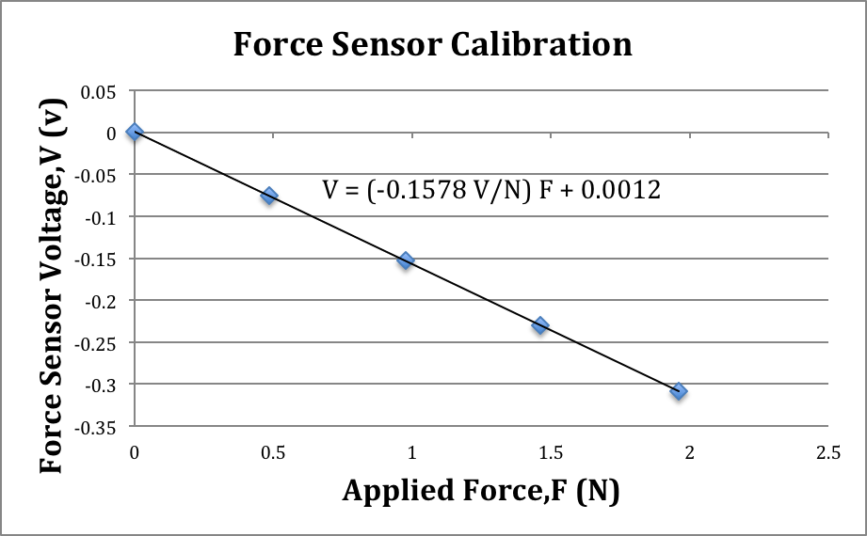

Figure 2: Voltage Correspondence to Force During Calibration; The blue points on the graph represent voltages that were measured from a force sensor after forces were applied. The trend line was generated with a tool in Microsoft Excel, and indicates linear correspondence between forces applied and voltages measured. The trend line is described by the equation V = (-0.1578 V/N) F + 0.0012, which is in the form V = aF + b.

**5.** The equation for the trend line in Figure 2 uses approximate numbers for the purpose of displaying a graph, but the data does not account for uncertainty. To include uncertainty, regression analysis was done with a regression tool in Microsoft excel.

|  |  |  |
| --- | --- | --- |
|  | Coefficients | Standard Error |
| Intercept | 0.001197319 | 0.000272657 |
| Slope | -0.157849321 | 0.000227697 |

Figure 3: Data From Regression; This table displays the raw data gathered from regression analysis in Microsoft Excel. This helps to calculate uncertainty in the linear trend.

The values gathered from the regression gives the following results:

Linear slope: a = (-0.1578 ± 0.0002) V/N

y-intercept: b = (0.0012 ± 0.0003) V

The nonzero y-intercept shows that the taring procedure still had some error. Although the procedure fixed large discrepancies, small variables such as the sensor’s imperfect internal mechanics, or minimal swinging of the weights were left unaccounted for, which may have slightly altered the readings.

**6.** In order to rewrite the calibration curve in a format that allows for the conversion of voltage to force, we can rearrange the equation V = aF + b (Eq. 0.1) by subtracting ‘b’ from both sides and dividing by a. Rearrangement leaves us with the equation:

F = $\frac{1}{a}$ V + ($\frac{-b}{a}$) (Eq. 6.1)

This new equation fits the form: F = cV + d, where c = $\frac{1}{a}$ and d = $\frac{-b}{a}$.

We can now calculate the values of c and d.

$$c= \frac{1}{a_{best}}= \frac{1}{-0.1578\frac{V}{N}}= -6.337\frac{N}{V}$$

$$d= \frac{-b_{best}}{a_{best}}= \frac{-(0.0012 V)}{-0.1578\frac{V}{N}}= 0.008 N$$

In order to calculate the uncertainty $δc$ based on the uncertainty $δa$, we can use equation ii.24 in the lab manual. This gives the equation:

$δc=\left|c_{best}\right|*\left|-1\right|*\frac{δa}{|a_{best}|}$ (Eq. 6.2)

By plugging in the uncertainty value of a, $δa$ = 0.0002 V/N, the best value of a, a = -0.1578 V/N, and the best value of c, c = -6.337 N/V, we can calculate $δc$ with equation 6.2.

$$δc=\left|-6.337\frac{N}{V}\right|*\left|-1\right|*\frac{0.0002\frac{V}{N}}{\left|-0.1578\frac{V}{N}\right|}$$

$δc=±0.008\frac{N}{V}$

We can use equation ii.14 in the lab manual to get $δd$.

$δd= \sqrt{{\left(\frac{δd}{δa}δa\right)}^{2}+{\left(\frac{δd}{δb}δb\right)}^{2}}$ at best, bbest (Eq. 6.3)

$\frac{δ}{δa} \left(\frac{-b}{a}\right)= \frac{b}{a^{2}}$ $\frac{δ}{δb} \left(\frac{-b}{a}\right)= \frac{-1}{a}$

$δd= \sqrt{{\left(\frac{b_{best}}{{(a_{best})}^{2}}δa\right)}^{2}+{\left(\frac{-1}{a_{best}}δb\right)}^{2}}$ (Eq. 6.4)

By plugging in the best calculated values for ‘a’ and ‘b’, as well as the uncertainty values $δa$ and $δb$, the uncertainty $δd$ can be calculated using equation 6.4.

$$δd= \sqrt{{\left(\frac{\left(0.0012 V\right)}{{\left(-0.1578\frac{V}{N}\right)}^{2}}(0.0002\frac{V}{N})\right)}^{2}+{\left(\frac{-1}{\left(-0.1578\frac{V}{N}\right)}(0.0003 V)\right)}^{2}}$$

$δd$ = ±0.002 N

The final equation is: $F = \left(-6.337±0.008\right)\frac{N}{V} V-\left(0.008±0.002\right)N$ (Eq. 6.5)

Equation 6.5 can be used to calculate the force based on input voltage.

**7.** As specified in the syllabus (page 3, Ver. 9/23/2015), students Frankie Fivefingers and Avril Armstrong may have attained different letter grades based on the grade distributions of their specific lab sections, despite initially having the same numerical scores. In order for this to occur, Frankie probably scored above the average mean numerical score in his class, while Avril likely scored below the average in her class. Since students in different sections may be graded differently based on their TA’s, students are evaluated based on the relationship between their grades and those in their same lab section. The original numerical score is not indicative of the final letter grade due to the nature of the curve.